11.03
Shop Planner
Process Design & AMOS Configuration Document
Purpose
This Process Design document is provided to Key-Users to record their key decisions regarding the AMOS Process design and the required AMOS configuration.
It is updated throughout the Project Definition Phase and used as the baseline for the Final Acceptance prior to Go-Live
Revision
Author, Name | Date | Notes
Paulo Reuter Perine | 01.06.2024 | First version

Table of Contents
1. Process Overview & Objectives 3
2. Regulatory References 3
3. Definitions & Glossary 3
4. Process Tasks 3
5. Process Dependencies 4
6. Process Flow 5
7. Process Design Questions 6
8. Data Source Mapping 7
9. Other Software Used 7
10. AMOS Configuration 7
a. Process specific configuration programmes 7
b. Basic Data 7
c. Parameters 8
d. Workflows 8
e. Scheduled Tasks 8
f. API’s & Interfaces 9
11. UAT Guidance 9
12. Annex – Additional Info 9

Process Overview & Objectives
Process General Description:
This process outlines the steps for fulfilling maintenance requests related to managed or non-managed components. The task flow covers various component repair scenarios and describes the necessary actions to consolidate repair demands into a manageable list. From there, you can review repair requests from your company or customers. Additionally, you can plan the initial shop scope, assign CAMO (Continuing Airworthiness Management Organization) scope for managed parts, or determine shop scope for both managed and non-managed components. Lastly, you have the option to deassign work scope before component induction. These actions are performed during the creation, editing, and planning of a component work package (CMWP).
Main Process Objective (Outputs & Outcomes):
The primary objective of this process is to enable the Shop Planner to strategically plan component maintenance, taking into account various requirements and the available capability and capacity of the shops. It offers the Shop Planner an overview of both internal and customer Rotable and Consumable Repairable components that require repair in the internal shop.

Regulatory References
There is no worldwide authority regulation applicable to this process.

Definitions & Glossary
Key-Words | Explanation
APN | AMOS Program Number.
CMWP | Component Maintenance Workpackage created in AMOS.
CAMO | Continuing Airworthiness Management Organization
R | Repair Order
RC | Customer Repair Order

Process Tasks
Business Process Task / Actions / Activities:
- Configure possible CMWP Statuses: Create necessary CMWP statuses, carefully selecting the actions that can be performed on each status. This configuration ensures that the appropriate teams have the necessary access rights at the right time.
- Review all shop input requests: Filter main components based on various criteria, including Part Number, Serial Number, internal/external origin, dedicated Owner, and ATA Chapter (as defined in Part Administration). Also consider Order Numbers (RC, RU, R order, and MP order).
- Scope, plan, update CMWP: Link/unlink R Orders to/from Component Workpackages, assign CAMO Scope, assign Shop Scope, and navigate to Resources Management modules. Actions like adding Component Requirements, Shopcards, and creating new Workpackages directly from the timeline are used for assigning Shop Scope and are subject to licensing. The deassign action handles both CAMO and Shop scope.
- Review and assign resources to CMWP: Assess the resources required for component repair, including staff to execute the work, materials, tools, and facilities.

Process Dependencies
INPUT | CONCURRENT | OUTPUT
- 10.06 – Inventory and Shelf-Life Control: Track inventory for part requirement due dates.  - 03.01 – Planning: Monitor the requirements due dates of the components installed at aircraft.  - 08.04 – Parts Removal and Installation: Track when a part is removed to perform maintenance in a shop.  - 09.04 – Repair and Exchanges: Issue repair order to repair the component.  - 10.07 – Customer Material: Issue RC order to repair customer component.  - 11.01 – Capability List: Create your own capability list and monitor your supplier’s capability list to identify who can execute the work needed on the component.  - 11.02 – Shop Card Templates: Create the work instruction to perform component maintenance and list all required resources to execute the work. | - 09.04 – Repair and Exchanges: Create external repair order when you plan the work scope to be executed by external shop. | - 11.04 – Component Maintenance: Release CMWP to shop.  - 09.04 – Repair and Exchanges: Issue CMWP for internal shop or R order to external shop.

Process Flow
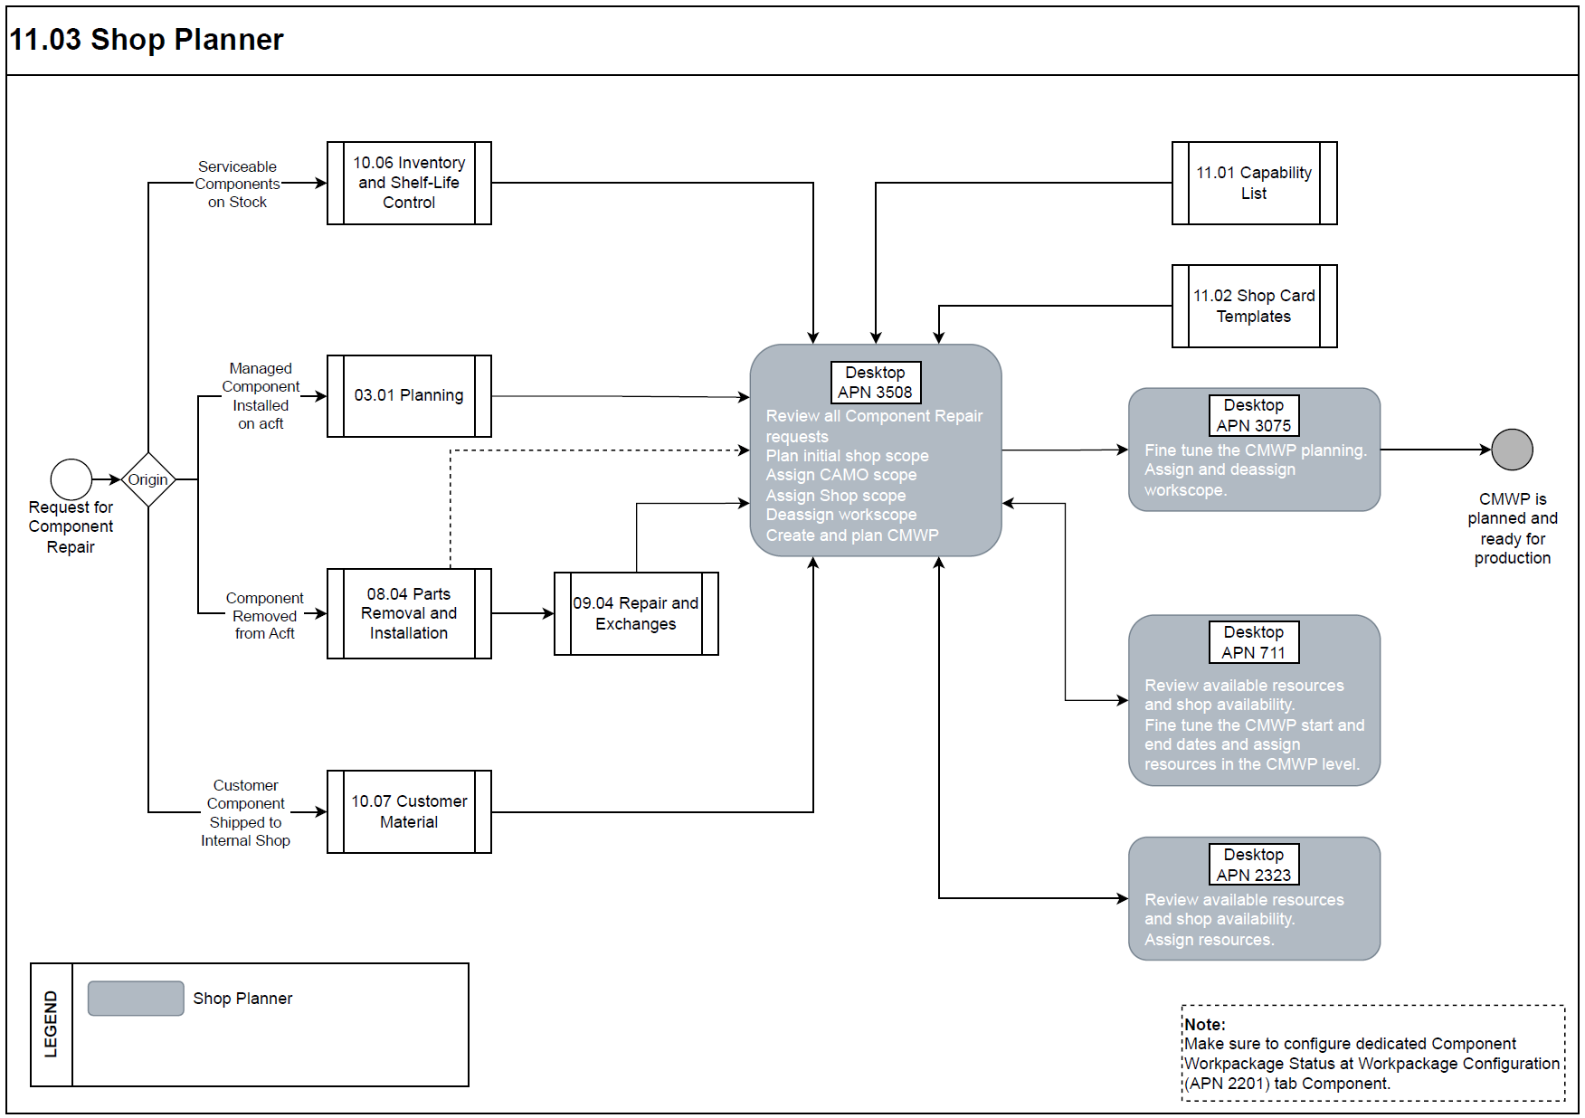

Process Design Questions
# | Question | Answer
1 | Who oversees shop planning in your organization?
2 | Do you have different departments planning internal shop work from external shop work?
3 | Managed Components: Who defines the work scope for the component repair?
4 | Non-manages components: Who defines the work scope of the component repair?
5 | Do you currently review if all required resources re available to perform the repair?
6 | How the component repair scope handover to your shop is done?

Data Source Mapping
Data Sources | Description | Volume / Manual / Automatic / Static / Dynamic
-/- | -/- | -/-

Other Software Used
Other Software | Used by: | Description
-/- | -/- | -/-

AMOS Configuration

Process specific configuration programmes
AMOS APN | Notes
Booking an order (ID:2) | Could be used to inform the CM shop of new "Customer Repair" order creation
Partno change on order (ID:53) | Could be used to inform the CM shop of Customer order change
Order Modification (ID:181) | Could be used to inform the CM shop of Customer order change
Generic Approval (ID:239) | This will trigger the request or changing of an approval request.
Book Order Detail (ID:242) | Before an order detail will be booked this workflow could be used to ensure all conditions are met
Issue Order (ID:302) | Before and after an order will be Issued this workflow could be used to ensure all conditions are met
Issue Order Detail (ID:352) | Before an order detail will be issued this workflow could be used to ensure all conditions are met

Basic Data
Basic Data Table | Notes
Condition | Indicates the condition of a rotable relative to its traceability as it moves through its life cycle process.
Incoterms | Incoterms (international commercial terms) are international sales terms.
Measure Unit | Defines the different measure units.
Order Priority | Priorities used on an order.

Parameters
Parameter Code | Parameter Name | Notes
1836 | Enable the upcoming event forecast calculation | used to enable / disable the automatic calculation of Component Planning data. | String Y
1843 | Enable the shop document forecast calculation | Used to enable / disable the forecast calculation of documents with following conditions:  - Document is marked as SHOP MAINTENANCE DOCUMENT.  - Document is a Component Modification. | String Y

Workflows
Workflow Number | Workflow Name | Workflow Setup Notes
2 | Booking an order | Could be used to inform the CM shop of new "Customer Repair" order creation
53 | Partno change on order | Could be used to inform the CM shop of Customer order change
181 | Order Modification | Could be used to inform the CM shop of Customer order change
239 | Generic Approval | This will trigger the request or changing of an approval request.
242 | Book Order Detail | Before an order detail will be booked this workflow could be used to ensure all conditions are met
302 | Issue Order | Before and after an order will be Issued this workflow could be used to ensure all conditions are met
352 | Issue Order Detail | Before an order detail will be issued this workflow could be used to ensure all conditions are met

Scheduled Tasks
Scheduled Task Reference | Frequency | Notes
ComponentMainteannceForecastService | Once a day | This scheduled task calculates the ToGo, Since Req and Expected Date of all events related to a Component and is strongly recommended for all supported AMOS Releases for performance and consistency reasons.
CapacityPlanningCalculationTask | Once a day | Computes capacity planning data of workpackages content based on workload distribution configuration

API’s & Interfaces
Reference | Direction | Trigger | Frequency
-/- | -/- | -/- | -/-

UAT Guidance
Test case number | Test case description | Required data | Required resources
01 | Open Component Planning APN 3508 to review the consolidated component repair demand. | Internal and external component due dates and repair data. | Shop Planner
02 | Create CMWP in advance on repair admin APN 1431 to better understand integration between the two APNs. | Internal and external component due dates and repair data. | Shop Planner
03 | Review part requirements and assign Requirements to CMWP in advance. Create a the CMWP. | Internal and external component due dates and repair data. | Shop Planner
04 | Assign resource to the CMWP | Staff qualification, shift plans, resources. | Shop Planner

Annex – Additional Info
-/-

